Climate Risk Report for Johannesburg

Author : Mbasa Issa Makolwa / 2883601

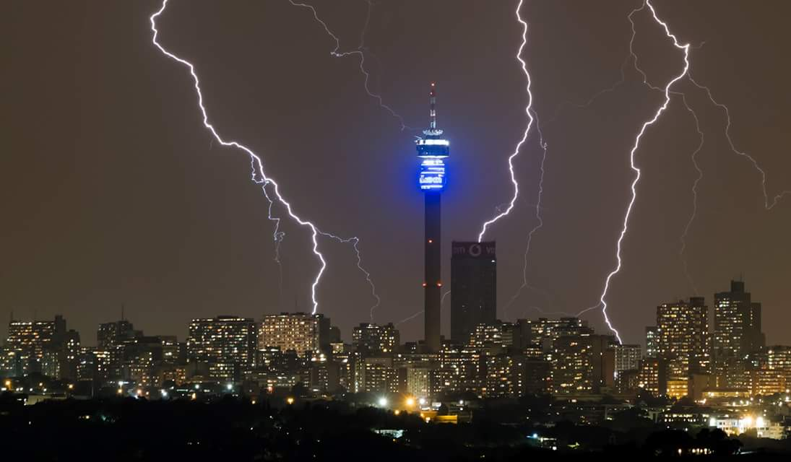

Introduction

Johannesburg, South Africa’s economic heart and most populous city, is becoming increasingly vulnerable to the impacts of climate change. Situated in the Gauteng Province, the city sits on a high plateau known as the Highveld and has historically experienced a temperate climate with distinct wet and dry seasons. However, the city is now facing more extreme and unpredictable climate conditions .These changes are not isolated; they are part of a broader pattern of climate phenomenon affecting sub-Saharan Africa. This report identifies and explains five major climate risks facing Johannesburg including increased temperatures and heatwaves, water scarcity and drought, extreme weather events, urban flooding, and ecological degradation. Each risk is looked at in the context of the city’s environmental, socio-economic, and infrastructural landscape.

1. Rising Temperatures and Heatwaves

Johannesburg has recorded an increase in average annual temperatures over the past few decades that is more than concerning , this is a trend that will accelerate. Research by Engelbrecht (et al. 2015) shows that southern Africa is warming at twice the global average , and major population centres such as Johannesburg are particularly vulnerable . According to the Climate Risk Profile for Southern Africa by Weathering Risk (2022), projections indicate that average temperatures in the region could rise by 1.9°C to 4.1°C above pre-industrial levels by 2080, depending on future greenhouse gas emissions. The increase in temperature has shown itself through more frequent and prolonged heatwaves, which have serious impacts for public health, urban infrastructure, and the already strained energy grid . High temperatures increased electricity demand due to the aggressive use of cooling systems , this issue will only serve to undermine efforts to restore the countries energy supply to full capacity . Additionally, the combination of high temperatures and below-normal rainfall raised concerns about water losses and lower water storage levels, affecting water management and energy demand (South African Weather Service, 2025).​Heatwaves increase the risk of heatstroke and dehydration, especially amongst vulnerable groups such as children, the elderly and people with chronic illnesses such as HIV and Aids . The Poorly ventilated and insulated housing in many of Johannesburg’s informal settlements further exacerbates the heat experienced by residents. Furthermore, rising urban temperatures contribute to the "urban heat island" effect, this is where dense urban areas become significantly warmer than surrounding rural areas, increasing the risks for city dwellers (IPCC, 2022). The Urban Heat Island effect also contributes to bad air quality this is even more concerning when one considers that a study by the Council for Scientific and Industrial Research (CSIR) revealed that areas within the Vaal Triangle already consistently exceed national air quality standards, contributing to higher incidences of respiratory ailments among residents (CSIR, 2013). Elevated temperatures accelerate the formation of ground-level ozone and other pollutants, which can exacerbate respiratory problems like asthma and bronchitis (Stone et al., 2010). All these health related risks will put a strain on the already fragile public health system in Johannesburg and in the long run affect the city’s economic competitiveness due to a less productive work force .
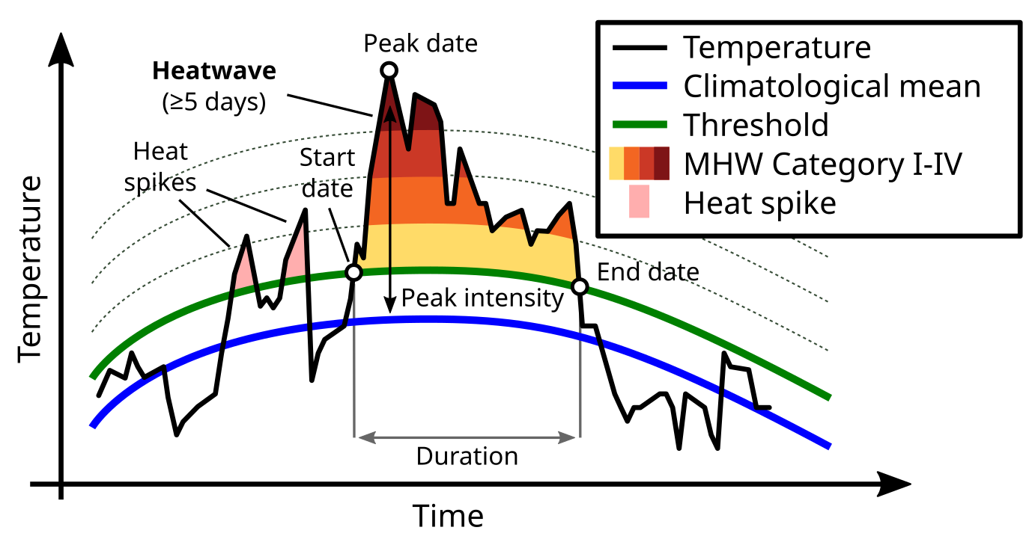
.Water Scarcity and Drought

Water scarcity is another significants threat to Johannesburg’s sustainability. The city is located very far from major water sources and relies mostly or primarily on water from the Vaal River system. These water systems are under growing pressure due to declining rainfall, rising temperatures, increased evaporation, and a growing urban population (DWA, 2013). Johannesburg Mayor Dada Morero has also acknowledged the severity of the crisis stating, "The unaccounted-for water lost through leaks is equally concerning. Better water demand management is required to address the excessive use and water losses" (Morero, 2024). Poor infrastructure maintenance has led to frequent pipe bursts and leaks, with estimates suggesting that up to 37% of potable water is lost through non-revenue water issues like leaks and illegal connections (City of Johannesburg, 2023). Joburg Water has also struggled with delayed repairs and aging infrastructure, which makes water outages longer and increases system inefficiencies. In some cases, miscommunication and poor crisis response during major supply disruptions — such as the prolonged Rand Water restrictions — have left residents without adequate access to water for extended periods (Nkosi, 2024). .Furthermore ​in recent years, Johannesburg has experienced periods of severe drought that have pushed water infrastructure to it’s limits . These droughts reduce surface and groundwater availability and impact agricultural productivity in surrounding rural areas and small community plots , this has a negative affect on food security and economic stability. ​As of 2021, approximately 6.4% of households in Gauteng province—which includes Johannesburg—were engaged in some form of agricultural activity, primarily for subsistence purposes (Statistics South Africa,2022). Subsistence farming serves as a crucial strategy for enhancing food security among urban and peri-urban households, particularly in the face of economic challenges and rising food prices (Baipheti & Jacobs, 2009).Moreover, water scarcity mostly affects low-income communities who often lack access to reliable water infrastructure. Water rationing, frequent supply interruptions and the use of unsafe water sources can lead to a waterborne diseases and social unrest due to frustration from communities on poor service delivery . The 2023 cholera outbreak in Gauteng, particularly in the Hammanskraal area, is a good example of the dire consequences of poor water delivery and infrastructure failures in vulnerable communities. These events in Pretoria set a precedent that could very easily be repeated in the city of Johannesburg but on a much larger scale .As the climate continues to shift, prolonged droughts are expected to become more frequent and intense , this will inturn exercebate the associated risks .
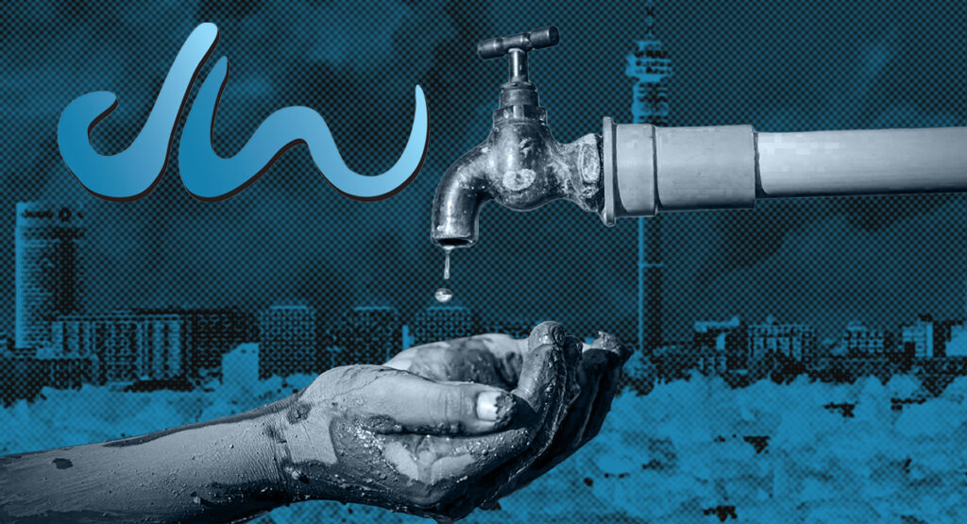

3. Extreme Weather Events

Johannesburg is increasingly experiencing intense and erratic weather events. These include events such as severe thunderstorms, hailstorms, and strong winds that cause significant damages to property, infrastructure, and ecosystems. Climate models predict a higher incidence of such events as atmospheric systems become more unstable due to global warming (IPCC, 2022). Just ​in March 2025, Johannesburg experienced severe flash floods following intense overnight thunderstorms. The flooding affected numerous neighbourhoods, including Weltevreden Park, Strubens Valley, Newlands, Parkhurst, and Randpark Ridge. Several bridges were submerged, and roads became impassable, leading to significant disruptions in daily activities (eNCA, 2025).​ More concerning is that Urban development in Johannesburg has often placed little regard for disaster management , with many vulnerable settlements lacking the basic infrastructure to withstand extreme weather. The city has also experienced frequent changes in leadership, with ten mayors over five years, leading to policy discontinuity and a lack of long-term planning especially with regards to natural disaster management . Corruption and mismanagement have further exacerbated the situation, resulting in deteriorating disaster management infrastructure and financial distress . One of the most notable impacts of thunderstorms in Johannesburg is the damage to infrastructure. Lightning strikes have been responsible for frequent power outages, fires, and damage to electronic systems. Public and private properties are also at risk, with reports of roof damage, shattered windows, and fallen trees being common after severe storms. For example , the major thunderstorm in March 2025 caused extensive damage in various parts of the city, with excessive lightning cited as a key factor in the storm's intensity (News24, 2025). In 2016, parts of the city were hit by a storm that caused widespread flooding and property damage, resulting in insurance claims exceeding R1 billion (South African Weather Service, 2017). Moreover, these events can cause injuries, displace families, and increase the financial burden on the already strained municipal resources. These extreme events while traditionally viewed as rare are becoming more common and more devastating , with their immediate effects being the most visible indicators for the impact of climate change .

4. Urban Flooding and Stormwater Management

Despite its elevation, Johannesburg faces a growing risk of urban flooding, primarily due to poor stormwater infrastructure, intense rainfall events, and the the high concentration of tared surfaces . Flash flooding has become a regular issue in the city’s low-lying areas, many of which are informal settlements built along floodplains or near rivers in Johannesburg's drainage systems, while some of the more formal settlements date back to the early 20th century and were not designed to cope with current or projected rainfall volumes . ​As of recent estimates, Johannesburg has approximately 181 informal settlements, accommodating around 180,000 households and a combined population exceeding 500,000 residents (City of Johannesburg, 2016). These settlements are dispersed across the city's various regions, including areas like Soweto, Diepsloot, and Orange Farm. They often lack adequate access to essential services such as water, sanitation, and electricity.​ The floods have also affected public health and safety. Waterlogged areas have made it challenging for communities to access health services. Frequent flooding events strain emergency services, which must allocate resources to rescue operations and manage traffic disruptions. This diversion of resources can impact the city's ability to respond to other emergencies effectively .​Blocked drains, illegal dumping, and poor maintenance have further reduced the effectiveness of the drainage systems, as a failure at one point affects the entire system . During periods of heavy rain, water rapidly accumulates and causes damage to homes, roads, and businesses. Floods also result in the contamination of water sources with sewage and waste, leading to outbreaks of diseases such as cholera and typhoid as previously mentioned .Additionally, climate change is projected to increase the intensity of rainfall during Johannesburg's summer months, compounding the risk of flash flooding (CoJ, 2018).

5. Ecological Degradation and Loss of Biodiversity

Climate change also threatens the integrity of Johannesburg’s natural environment. The city, even though it is highly urbanized, contains critical ecosystems such as grasslands, wetlands, and riparian zones. Rising temperatures together with erratic rainfall patterns have led to the drying of wetlands in the Gauteng Province. A study by Belle (2018) emphasizes that climate change affects the hydro-period of wetlands—the
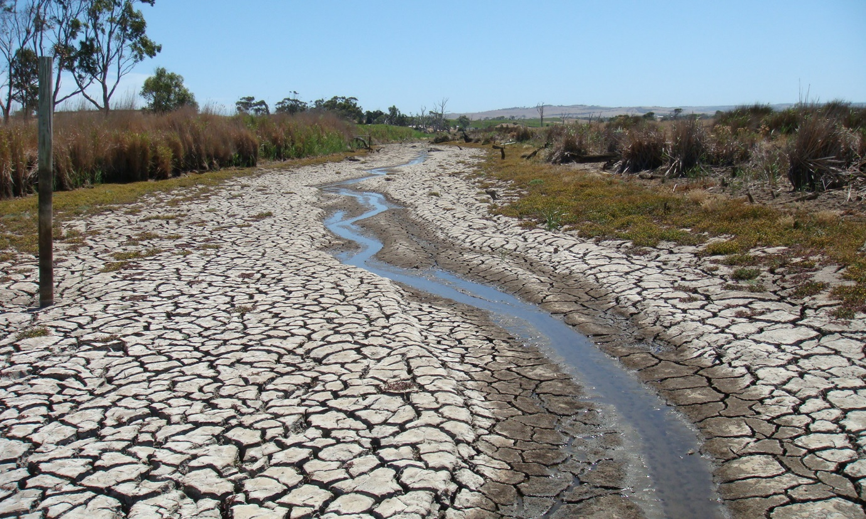
duration and frequency of wet conditions essential for wetland ecosystems. Alterations in these patterns result in the loss of wetland functionality and biodiversity. The Kaalfontein wetlands in Midrand have experienced significant degradation due to climate change . The destruction of wetlands in and around Johannesburg has significant negative consequences for both the ecosystem and the human population. Wetlands provide essential ecological services, including water purification, flood control, groundwater recharge, and biodiversity support. Their destruction due to climate change, pollution, and urban encroachment threatens to disrupt these critical functions, resulting in environmental and socio-economic harm. Additionally rising temperatures, shifting rainfall patterns, and uncontrolled urban sprawl are leading to habitat loss, soil degradation, and reduced biodiversity. This Ecological degradation significantly weakens the city's natural defences to fight against climate hazards. For example the loss of wetlands reduces the landscape’s ability to absorb stormwater, increasing flood risk. Moreover, less biodiverity reduces the resilience of the environment to pests, diseases and further climatic changes. Tourists' perceptions of climate change impacts can influence their travel decisions. A study focusing on Johannesburg found that visitors reported concerns about water scarcity, disruption of recreational activities, and the destruction of habitats due to climate change (Rogerson & Rogerson, 2024). Such perceptions can lead to a decline in tourist arrivals, affecting the local economys .So the destruction of the environment should not only be viewed as only having a negative impact on the environment because the environment and society as a whole share a symbiotic relationship .

Which of these risks can be transferred
The nature of extreme weather events means that they are quantifiable, random and insurable under typical terms and conditions of general insurance contracts. Unlike the more slow acting climate risks such as ecological degradation or rising temperatures, extreme weather events are defined by immediate loss events that can be directly linked to claims, making them highly relevant to insurers (IPCC, 2022). In fact the report mentions that a 2016 storm in Johannesburg resulted in insurance claims exceeding R1 billion (South African Weather Service, 2017). This shows not only the economic significance of such events but also the very important role that the insurance industry already plays in mitigating them. Globally, similar trends can be seen for example, in 2021 Europe experienced catastrophic flooding in Germany and Belgium, resulting in over €11 billion in insured losses (Swiss Re Institute, 2022). In the United States, Hurricane Ian in 2022 led to approximately $60 billion in insured damages, showcasing how insurance markets have historically responded to extreme weather (Insurance Information Institute, 2023). These examples are relevant in regards to Johannesburg’s risks and clearly shows that insurers have models and mechanisms capable of adapting to and pricing for these hazards .However, transferring this risk to the insurance market is not simple . In Johannesburg, infrastructure decay, poor disaster preparedness, and limited enforcement of building codes exacerbate such vulnerability. The report notes that changes in municipal leadership and widespread mismanagement have resulted in underinvestment in infrastructure, making insured assets more exposed and possibly uninsurable at a reasonable cost (BusinessTech, 2024). For insurance to function effectively, a level of risk mitigation must be in place ,otherwise insurers may raise premiums or withdraw altogether.Parametric insurance products , where payouts are triggered by an objective and verifiable proxy such as rainfall intensity or wind speed, offer an the most practical and fair way to deal with this uncertainty. These have been successfully tested in sub-Saharan Africa through programs like the African Risk Capacity (ARC), which insures governments against climate-related disasters. Expanding similar frameworks to the municipalities level like in Johannesburg could help manage risk while promoting resilience (African Risk Capacity, 2023).
Conclusion
Johannesburg faces a complexed and growing set of climate risk that threaten its infrastructure, public health, economic stability and ecological integrity. Rising temperatures, water scarcity, extreme weather events, urban flooding and ecological degradation are connected challenges intensified by rapid urbanization and inadequate governance. Among theses , extreme weather events stand out as the best to transfer to the insurance markets due to their sadden and measurable impacts. However, successful risk transfer depends on improved infrastructure, proactive governance, and active risk mitigation. As climate change accelerates, Johannesburg must integrate adaptive planning, community resilience, and innovative financial tools like parametric insurance to protect its future. Addressing these challenges is not only vital for environmental sustainability but also for the city’s long term socio-economic well-being.

References

City of Johannesburg (CoJ). (2018). Integrated Development Plan 2018/19 Review. Johannesburg: CoJ.

Department of Water Affairs (DWA). (2013). National Water Resource Strategy (NWRS2).
Pretoria: Republic of South Africa.

Engelbrecht, F. A., Adegoke, J., Bopape, M. J., Naidoo, M., Garland, R., Thatcher, M., ... & McGregor, J. (2015). Projections of rapidly rising surface temperatures over Africa under low mitigation. Environmental Research Letters, 10(8), 085004.

Intergovernmental Panel on Climate Change (IPCC). (2022). Climate Change 2022: Impacts, Adaptation and Vulnerability. Contribution of Working Group II to the Sixth Assessment Report. Cambridge University Press.

South African National Biodiversity Institute (SANBI). (2019). State of Biodiversity Report 2019. Pretoria: SANBI.

South African Weather Service. (2017). Annual Climate Summary 2016. Pretoria: SAWS.
New, M., Osborn, T. J., & Hulme, M. (2023). Observed trends in climate over Southern Africa: 1980–2018. Journal of Climatology. Retrieved from https://rmets.onlinelibrary.wiley.com/doi/10.1002/joc.7295
Council for Scientific and Industrial Research (CSIR). (2013). Air quality and respiratory health in the Vaal Triangle. CSIR

Weathering Risk. (2022). Climate Risk Profile: Southern Africa. Retrieved from https://weatheringrisk.org
Morero, D. (2024). Johannesburg is facing a severe water crisis. The Mail & Guardian. Retrieved from https://mg.co.za/the-green-guardian/2024-10-31-dada-morero-joburg-is-facing-a-severe-water-crisis/
Baipheti, M. N., & Jacobs, P. T. (2009). The contribution of subsistence farming to food security in South Africa. Human Sciences Research Council. Retrieved from https://miriamaltman.com/wp-content/uploads/2016/09/AGRIFS003_Baipheti_Jacobs_subsistence_farming.pdf

Statistics South Africa. (2022). Census 2022 Agricultural Households. Retrieved from https://www.statssa.gov.za/publications/Report-03-11-01/Report-03-11-012022.pdf
National Institute for Communicable Diseases. (2023, March 30). Cholera Outbreak in South Africa. Retrieved from https://www.nicd.ac.za/cholera-outbreak-in-south-africa-30-march-2023/
BusinessTech. (2024, February 25). South Africa’s most important city collapsing in front of everyone’s eyes. Retrieved from https://businesstech.co.za/news/government/812715/south-africas-most-important-city-collapsing-in-front-of-everyones-eyes/
The Bulrushes. (2025, April 18). Easter Weekend Wet Weather: Gauteng Emergency Services On High Alert. Retrieved from https://thebulrushes.com/2025/04/18/easter-weekend-wet-weather-gauteng-emergency-services-on-the-ready/​

Belle, J. A. (2018). Managing Wetlands for Climate Change Adaptation: A Case Study. International Journal of Scientific Research and Management. Retrieved from https://ijsrm.humanjournals.com/wp-content/uploads/2018/04/1.Johanes-A.-Belle.pdf

Johannesburg City Parks and Zoo (JCPZ). (2024). Joburg Wetlands & River Systems. Retrieved from https://www.jhbcityparksandzoo.com/services-facilities/ecological-services/joburg-wetlands-river-systems
Rogerson, J. M., & Rogerson, C. M. (2024). Climate change perceptions and experiences from tourists visiting Johannesburg, South Africa. Cogent Social Sciences, 10(1), 2407024. https://doi.org/10.1080/23311886.2024.2407024
African Risk Capacity. (2023). ARC Group Annual Report 2022. https://www.africanriskcapacity.org

BusinessTech. (2024, February 25). South Africa’s most important city collapsing in front of everyone’s eyes. https://businesstech.co.za/news/government/812715/south-africas-most-important-city-collapsing-in-front-of-everyones-eyes/

eNCA. (2025). Flash floods wreak havoc in Johannesburg suburbs. Retrieved from https://www.enca.com

Insurance Information Institute. (2023). Hurricane Ian cost estimates. https://www.iii.org

Intergovernmental Panel on Climate Change (IPCC). (2022). Climate Change 2022: Impacts, Adaptation and Vulnerability. Cambridge University Press.

South African Weather Service. (2017). Annual Climate Summary 2016. Pretoria: SAWS.

Swiss Re Institute. (2022). Natural catastrophes in 2021: the flood gates are open. https://www.swissre.com
City of Johannesburg. (2023). Annual report: Water and sanitation services 2022/2023. https://www.joburg.org.za

Nkosi, N. (2024, February 18). Water woes deepen as Joburg Water scrambles to fix leaks. The Star. https://www.iol.co.za/thestar

